CYNGOR CYMUNED LLANTYSILIO COMMUNITY COUNCIL

Clerc y Cyngor  Mr R. A. Evans  Llwyn Celyn, Ffordd Salop, Owrtyn, Wrecsam  LL13 0EH  Ffon: 07730876524  Ebost:llantysilio.cc@btinternet.com | 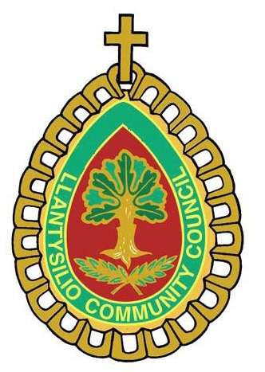 | Clerk to the Council  Mr R. A. Evans  Llwyn Celyn, Salop Road, Overton, Wrexham  LL13 0EH  Tel: 07730876524  Email: llantysilio.cc@btinternet.com

Join Your Community Council – Make a Difference!
Casual Vacancy for a Community Councillor
Llantysilio Community Council is seeking a passionate and dedicated individual to fill a vacancy on our Council through co-option. This is your chance to represent our local area, to shape local decisions, and contribute to the heart of our vibrant community.
We’re Looking For:
- A resident of the Llantysilio community (or within 3 miles of the boundary)
- Aged 18 or over
- Enthusiastic about improving local services, facilities, and community life
- Committed to attending regular meetings and engaging with residents
- No prior experience needed – just a desire to make a positive impact!
Why Join Us? As a Community Councillor, you will:
- Have a voice in local projects, from green spaces to community events
- Work with a dedicated team to address local issues
- Help preserve and promote our unique Welsh culture and heritage
- Gain skills in leadership, teamwork, and community engagement
How to Apply: If you’re ready to make a difference, please submit a short statement (max 500 words) outlining why you’d like to be a Councillor, what you can bring to the role and confirming your eligibility to serve on Llantysilio Community Council. Email your statement to llantysilio.cc@btinternent.com or post to the Clerk at the address above by August 31st, 2025.
Be a voice for Llantysilio – Apply Today!

